**[Project Name]**

Simplified Agile SRS

[author(s)]

[date]

Revision History

|  |  |  |  |
| --- | --- | --- | --- |
| Rev | Date | Description of Change | By |
| 1.0 | [date] | Describe change | [author(s)] |

Table of Contents

Revision History ii

Section 1: Introduction 1

Section 1.1: Purpose 1

Section 1.2: Scope 1

Section 1.3: Definitions, Acronyms, and Abbreviations 1

Section 1.4: References 1

Section 1.5: Overview 1

Section 2: Overall Description 1

Section 2.1: Product Perspective 1

Section 2.1.1: User Interfaces 1

Section 2.1.2: Software Interfaces 2

Section 2.1.3: Operations 2

Section 2.2: Product Functions 2

Section 2.2.1: Function #1 2

Section 2.3: User Characteristics 3

Section 2.4: Constraints 3

Section 2.4.1: Regulatory policies 3

Section 2.4.2: Hardware limitations 3

Section 2.4.3: Interfaces to other applications 3

Section 2.4.4: Parallel Operation 3

Section 2.4.5: Audit Function 3

Section 2.4.6: Control Functions 3

Section 2.4.7: Reliability Requirements 3

Section 2.4.8: Criticality of the Application 4

Section 2.4.9: Safety and Security Considerations 4

Section 2.5: Assumptions and Dependencies 4

Section 2.6: Apportioning of Requirements 4

Section 2.7: Software System Attributes 4

Section 1: Introduction

## Section 1.1: Purpose

[describe the purpose of the software system]

## Section 1.2: Scope

[describe the scope of the project]

## Section 1.3: Definitions, Acronyms, and Abbreviations

**Table 1.**

*Definitions, Acronyms, and Abbreviations for the Project*

|  |  |
| --- | --- |
| Name | Description |
| [item] | [description] |
| (repeat as needed) |  |
|  |  |
|  |  |
|  |  |
|  |  |
|  |  |

## Section 1.4: References

1. Provide IEEE formatted references (cite them using [1] [2], etc. IEEE citation method)

## Section 1.5: Overview

[provide a system overview]

Section 2: Overall Description

## Section 2.1: Product Perspective

[provide a product perspective description – include block diagrams and other details to help clarify and disambiguate]

### Section 2.1.1: User Interfaces

[provide wireframe examples of expected user interaction with system]

### Section 2.1.2: Software Interfaces

[describe how the system interacts with other systems (interfaces / APIs)]

### Section 2.1.3: Operations

[describe modes of operation]

## Section 2.2: Product Functions

[describe product functionality – high level]

### Section 2.2.1: Function #1

[describe first function – repeat section 2.2.X for all required functionality – note, this may be a higher level grouping of functions (e.g. web functions, embedded systems functions, etc., thus, the individual functions below each of the higher level groupings would have another level of heading nesting]

**Figure X.**

*[Use Case Diagram and Label (example use case diagram below)]*

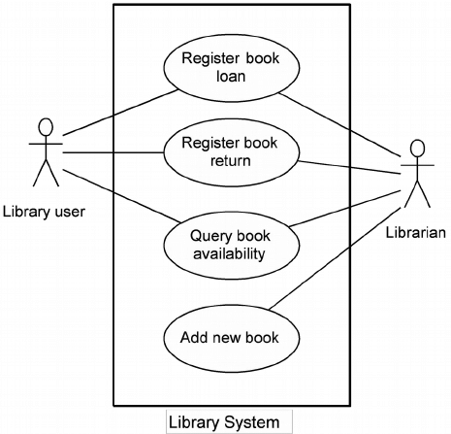

#### Overview:

[describe the use case]

#### Notes:

[describe any notes the reader should be aware of]

#### Actors:

[describe who is interacting with this use case]

#### Preconditions:

[what conditions exist for this use case]

#### Use Case Details

**Table X.**

|  |  |
| --- | --- |
| Goal: | [describe goal of use case] |
| Actor(s): | [describe who interacts with this use case] |
| Trigger: | [describe how this use case is activated] |
| Success Outcomes: | [describe what happens if the use case succeeds] |
| Exceptions: | [describe what happens if the use case fails] |

#### UI Mock-ups:

[insert additional wire frame mock-ups unless already included in section 2.1.2]

#### Scenario Notes:

[additional notes regarding the use case scenarios]

## Section 2.3: User Characteristics

[describe the characteristics of the users of the system]

## Section 2.4: Constraints

[describe the overall constraints of the system]

### Section 2.4.1: Regulatory policies

[describe specific regulatory constraints]

### Section 2.4.2: Hardware limitations

[describe any hardware constraints]

### Section 2.4.3: Interfaces to other applications

[describe constraints related to interfaces to other systems / applications]

### Section 2.4.4: Parallel Operation

[describe any potential parallel operation considerations]

### Section 2.4.5: Audit Function

[describe how the project will be monitored for success]

### Section 2.4.6: Control Functions

[describe any system control requirements]

### Section 2.4.7: Reliability Requirements

[describe requirements for system reliability]

### Section 2.4.8: Criticality of the Application

[describe any requirements in terms of critical roles the project plays]

### Section 2.4.9: Safety and Security Considerations

[describe any security / privacy requirements]

## Section 2.5: Assumptions and Dependencies

[describe any assumptions made and dependencies on other projects / SRS]

## Section 2.6: Apportioning of Requirements

[describe any requirements that may be deferred]

## Section 2.7: Software System Attributes

[describe each of the following using must/should/could/won’t language (MuSCoW]

AVAILABILITY:

RELIABILITY:

SECURITY:

MAINTAINABILITY:

PORTABILITY:

[add other attributes as needed]